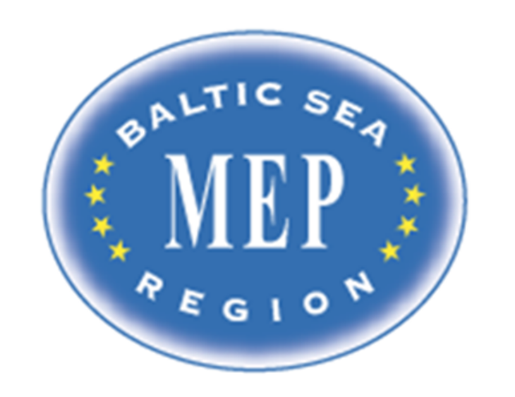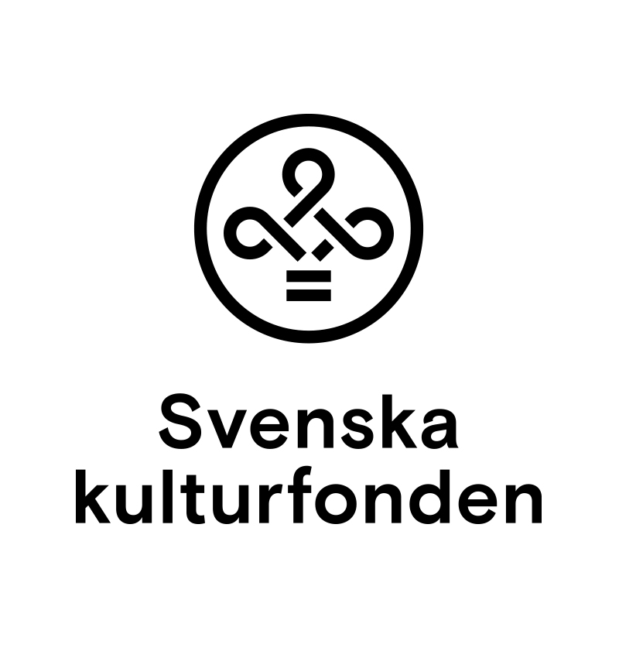

**Presidents and Committee Issues**

**BSR MEP Finland 2025**

# Presidency

President Aarna Kapadia, Finland

Vice-President Andre Sepp, Estonia

# Committee Presidents and Issues

## Committee on Industry, Research and Energy (ITRE)

Vincentas Jovaiša, Lithuania

Lisa Stoehr, Germany

**The Question of EU Space Exploration and Innovation**

The European Union has a limited capacity for autonomous space access and is becoming increasingly reliant on third countries for critical space infrastructure. In 2023, for example, the EU conducted only three (3) successful orbital launches, compared to 109 by the United States and 66 by China. The EU has also faced delays with the Ariane 6 rocket, which was originally scheduled for launch in 2020 and is now expected to launch in mid-2025. Meanwhile, key space-related services such as satellite internet are dominated by foreign entities like SpaceX’s Starlink, which controls over 60% of all active satellites in low-Earth orbit.

How can the EU strengthen its position in space innovation and reduce dependency on foreign powers while maintaining international cooperation?

## Committee on Security and Defense (SEDE)

Gustaf Ahlqvist, Sweden

Floor Anderiesse, the Netherlands

**The Question of the Russian Shadow Fleet and Possible Proxies Operating in the Baltic Sea Area**

The Baltic Sea is one of Europe’s main transport routes. Since Russia’s invasion of Ukraine, the European Union has imposed economic sanctions in an effort to limit Russia’s ability to wage war. In response, Russia has established a so-called “shadow fleet” to transport oil and other goods. This fleet primarily operates at the Baltic Sea with uninsured vessels outside the scope of international maritime regulations and it poses a threat in the form of hybrid warfare, sabotage operations, and significant environmental risks.

How could the European Union more effectively restrict the operations of the Russian shadow fleet and other potential proxies?

## Committee on Economic and Monetary Affairs (ECON)

Milla Jalasto, Finland

Artur Tritt, Poland

**The Question of EU Economic Resilience in the Face of Unpredictable US Trade Policy**

The European Union's commitment to predictable, rules-based trade is challenged by the volatile trade policy of the United States. The imposition of a universal 10% tariff and higher tariffs on specific EU goods like steel, aluminum, and automotive exports in March 2025 caused immediate economic disruption. The subsequent 90-day postponement of higher tariffs highlighted the unpredictable nature of US policy, complicating long-term planning for EU businesses.

How can the EU develop effective and adaptive strategies to strengthen its economic resilience and protect its interests amidst the United States' unpredictable tariff policies?

## Committee on the Environment, Public Health and Food Safety (ENVI)

Mads Bundvig, Denmark

Lara Oluc Chitic, Norway

**The Question of Water Pollution in the Baltic Sea**

In the most recent report (2023) from HELCOM (an intergovernmental organization bridging policy and science on matters related to the environment of the Baltic Sea), it was found that pollution is one of the main causes for the poor state of the Baltic Sea.

How can the EU reduce the harm caused by pollution to the Baltic Sea?

## Committee on Culture and Education (CULT)

Matteus Viitanen, Finland

Alice Kangro, Estonia

**The question of promoting linguistic diversity**

The EU is home to rich cultural, linguistic, national and regional diversity. Commitment to linguistic diversity is an explicit objective that is outlined in multiple policies related to language rights in the European Union. The EU Charter of Fundamental Rights forbids discrimination on the grounds of language. In several member states there is legislation in place outlining language policy which contains provisions relating to the needs of minority language speakers. In spite of national and international regulations, their enforcement is often lacking.

How can the EU ensure its stated language policy is implemented in all member states in a time of economic and political turbulence?