Model European Parliament
Baltic Sea Region
Sønderborg, Denmark
Oct 2-7, 2018
PROGRAM

MEP BSR Session in Sønderborg, Denmark
Tuesday, October 2nd

Before 18.00 Arrival of delegations from Hamburg and Copenhagen
Pick up by guides and transfer to
Alssundgymnasiet Sønderborg
Grundtvigs Allé 86
6400 Sønderborg
Telefon: 74 42 05 01
www.ags.dk

Contact person: Jens C. Verdoner

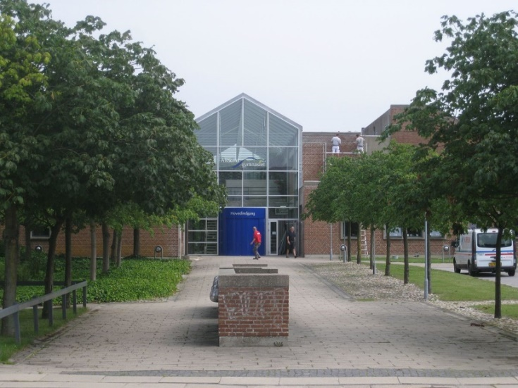

Host families pick up their guests at Alssundgymnasiet
Evening Delegates have dinner and spend evening with their host families
or at hostel

Teachers/Directors stay at Hotel 6400, Solglimt 6, DK 6400 Sønderborg https://www.hotel6400.dk/en/
or at Sønderborg Vollerup Danhostel
www.danhostel-sonderborg-vollerup.dk

20.00 Dinner and welcome briefing for teachers/directors
Wednesday, October 3rd

09:00-10:00 Opening Ceremony at Sønderborg Castle

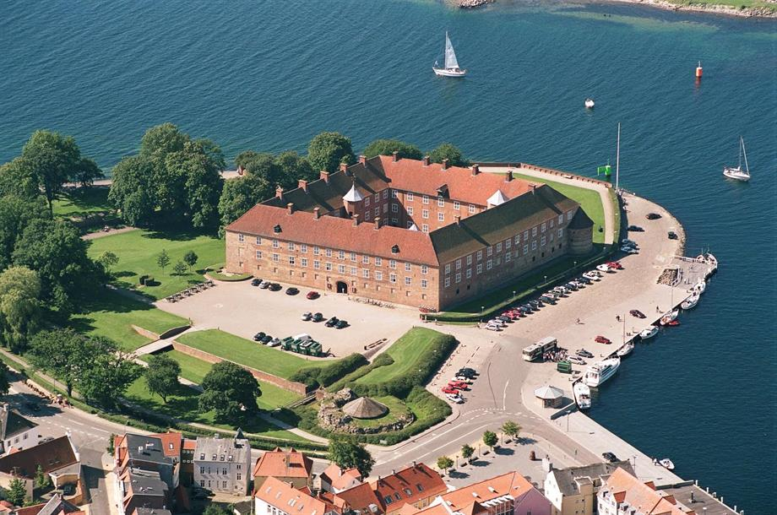

Delegates and teachers/directors have to be present at 08:30

Speakers:

- Mr. Dan Gustafsson, Chairman of the Board of MEP BSR
- Mr. Erik Lauritzen, Mayor of Sønderborg
- Mr. René Rasmussen, Museum Curator, Sønderborg Castle
- Heads of Delegations
- Introduction to CPs by Presidents Simon Ulvsgaard and Maria Buhl Christensen

10.30 Team building activities

12.30-13.30 Lunch/ Meeting for Presidents/cps/media group

13.30-17.30 Committee Meetings at Alssundgymnasiet

14.00-16.00 MEP BSR Board Meeting for Teachers/Directors
Location: Alssundgymnasiet

Evening Delegates have dinner with host families or at hostel

Teachers/Directors have dinner on their own account

Thursday, October 4th

09.00-16.00 Committee Meetings continued at Alssundgymnasiet

Resolutions to be handed in at 16.00

16.00-18.00 Correction Panel, printing of resolutions

17.30/18.00 Buffet at Peking Restaurant, Jernbanegade 49 (2 groups)

19.00-21.00 Cultural Evening at Multikulturhuset, Nørre Havnegade 15

Friday, October 5th

10.00-13.00 Delegation Meetings at cafées downtown
Lobbying in Multikulturhuset, Nørre Havnegade 15

Lunch

14.00-17.00 Excursion to Dybbøl/History Center Dybbøl Banke
http://1864.dk/begivenhed/fall-break/?lang=en

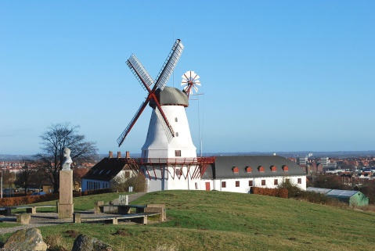

Evening Delegates have dinner with host families or in town/Game night
https://www.facebook.com/sdb.ungdomscafe/ Løngang 29

Teachers/Directors have dinner on their own account

Saturday, October 6th

09.30 General Assembly at SDU/Alsion (U101)
www.sdu.dk

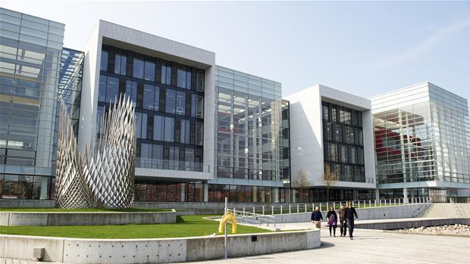

Delegates and Teachers/Directors must be present at 08.30

- Opening by GA Presidents Simon Ulvsgaard and Maria Buhl Christensen

Three resolutions in the morning (coffee break in between)

13.00-14.00 Lunch

14.00-17.15 Three resolutions in the afternoon (coffee break in between)

17.15-17.30 Closing Ceremony

Speakers:
- Presidents of the GA
- Mrs. Nina Nørgaard, Administrative Coordinator of MEP BSR

18.00-20.00 Buffet/Social Evening at ASG

Sunday, October 7th

Departure all delegations

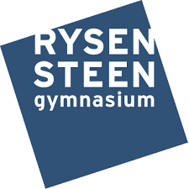

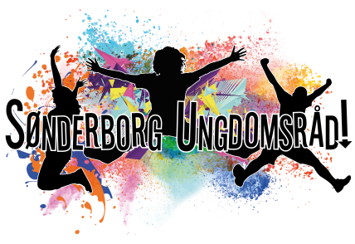

www.mepbsr.org

