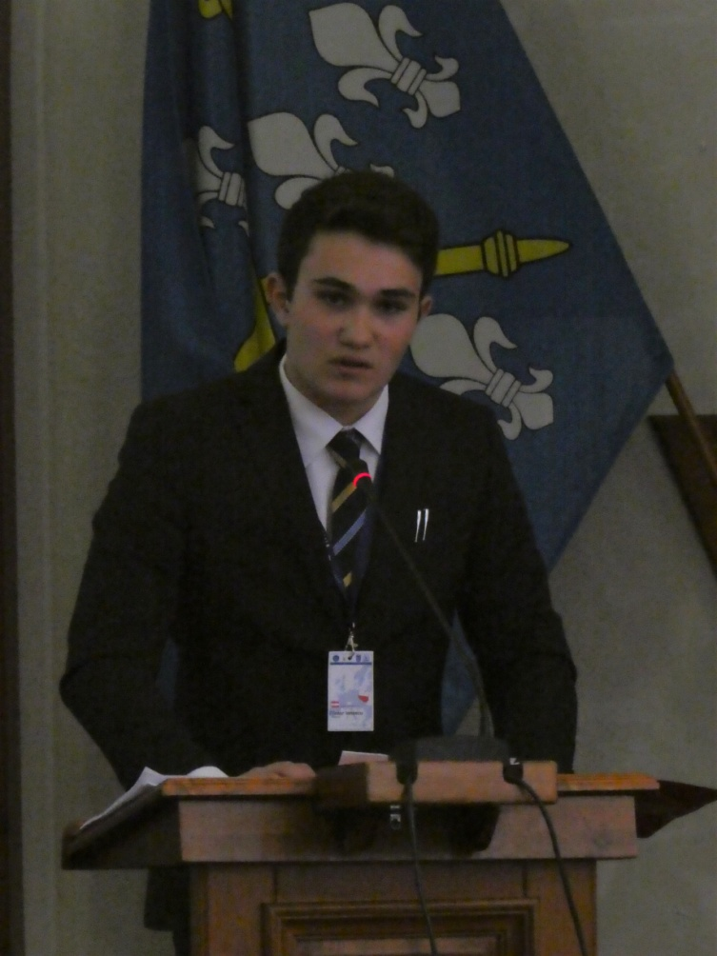
Dear delegates,

My name is Tudor Ionescu and I am one of the representatives of the Austrian Delegation. I am pleased to have been appointed as Committee President for the Committee on Culture and Education and am I very much look forward to meet every one of you in Sønderborg, Denmark.

I am 16 years old and I currently attend the high school at Theresianische Akademie in Vienna, the beautiful capital of Austria. Foreign Affairs and Politics are amongst my favorite subjects in addition to learning three languages. Swimming and theater are my additional interests and hobbies.

The themes which are covered by our Committee are fundamental for the shape of the future of the European Union.

Therefore, our outcome shall consider every EU Member State’s interests.

We will not only be debating these subjects, but we have to think and identify solutions for the present problems which will be beneficial for the entire EU and the citizens of the EU. The culture and education are important, if not the most important, domains considering. It will not always be easy to come to good solutions.

Our tasks are challenging but I am convinced that we will manage to find the most convenient and safest way to further equal education in the European Union.
I would also like to put an emphasis on the fact that the proper substantive preparations are the key to a successful and valuable discussion as well as to good results. Therefore, I would really like to encourage you to study carefully the attached materials.

I am providing you with some useful links where additional information can be found. Prior to the session, I would kindly ask you, in addition to your own research, to read this information too so that we can get straight into discussing the issue of equal education in Europe and what the European Union can do to tackle this issue.

I look forward to working with you all and am confident that we will (as they say in MEP) have very productive debates and a fruitful exchange of views with a view to identify together feasible and sustainable solutions.

Please do not hesitate to contact me by e-mail (tudorionescu5000@gmail.com) if you have any questions.

In Austria, the summer holiday will start in three weeks. I wish you all a wonderful summer break, with a lot of joy and relaxing time.

With my best regards,
Tudor

Links: https://ec.europa.eu/youth/
https://ec.europa.eu/info/departments/education-youth-sport-and-culture_en

