Honourable Delegates,
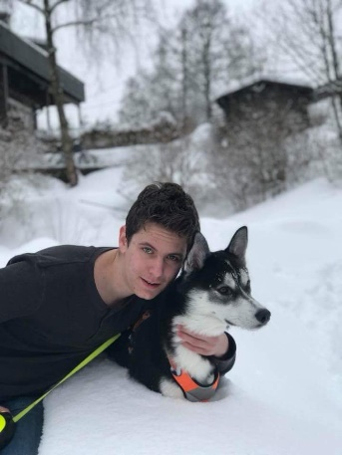
Welcome to the Committee on Foreign Affairs. I look forward to meeting you all in Denmark and hearing all your interesting ideas, discussions and contributions to the MEP BSR conference in Sønderborg this Autumn. My name is Thomas Anders Reed, and am currently in my first year of the International Baccalaureate Diploma Program, at Nesbru High School, Norway. I have always enjoyed debating, as well as politics (which go hand-in-hand with each other), and MEP has been a perfect forum for me to do such. During my last session in Poland I met many people, from many backgrounds and with different sides to every argument. I hope that all of you will share such an experience at this upcoming MEP session in Denmark.
Our committee will address the following issue:

The question of security in the Baltic Sea Region. The Baltic sea region is a zone of heightened tensions between Moscow and the West. Russia has increased its military capability in its Baltic enclave of Kaliningrad, while NATO has stationed anti-missile shields in eastern Europe. How can conflicts and further escalation be avoided and dialogue between the EU and Russia be promoted? In what ways might international organizations assist in this process?

The issue of security in the Baltics is a very delicate topic to say the least, as we will be dealing with the opposing views between not only east and west, but also the EU’s involvement in this issue, as many member states of the EU are also members of NATO. This is an issue which will require incredible specific solutions to please all countries involved in the matter, and because of this I urge you all to research further than just the two links I will provide as I alone cannot find all the information regarding this issue. I urge you to evaluate your sources, and try to find the most neutral sources as possible, because it is very easy to find sources elevating one party over the other. This will also help you get a broader view of the issue, and the more information you have available, the better you will do during resolution writing and during the General Assembly.

If you need help or advice with anything, do not hesitate to contact me at: reed.thomasanders@gmail.com

I wish you all the best of luck, and look forward to seeing you all in Denmark!

Thomas Anders Reed
Committee President of Foreign Affairs (SEDE)

Link 1: https://eeas.europa.eu/headquarters/headquarters-Homepage/28286/eu-nato-cooperation-factsheet_en (This gives an overview of EU-NATO Relations)

Link2: https://carnegieendowment.org/2018/03/28/preventing-escalation-in-baltics-nato-playbook-pub-75878 (More specific information about the issue we will be dealing with)

