Distinguished delegates,
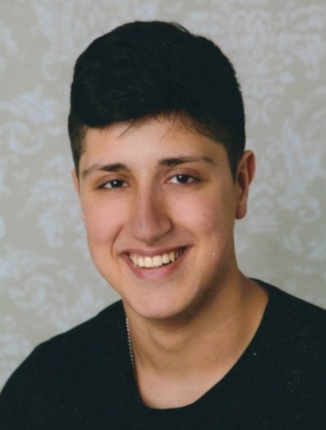
Welcome to the Committee on Constitutional Affairs. I am looking forward to meeting you all at the MEP BSR in Denmark, Sønderborg. I expect some really good ideas about the topic of our committee and animated discussions. My name is Mervan Vural and I am from the capital of Germany, Berlin. Currently I am in my last year of high school. I am really interested in politics, especially international and European politics. I think MEP is the best platform to give us a better understanding of the European Union. This will be my sixth MEP session and I hope, you will have the same wonderful experience at the BSR as I had on all my MEP sessions.
In our committee we will discuss the following issue:
The question of break-away regions in the EU. When the integrity of its nation states comes under threat and attack the EU cannot keep a safe distance from events unfolding. Regions aspiring to independence have already started to ask disturbing questions, e.g. about EU membership. What approaches should the EU take in such situations?
The states of the European Union more and more face the problem of regions trying to get their independence. But what happens if a part of an EU member state, e.g. Catalonia in Spain, gets its independency? Will they remain in or leave the EU? Even though this is a national problem, it affects the whole European Union. You all together will have to discuss how the EU should act in such cases. Always remember that team work is very important while you work on your resolution in the committee.
I urge you to research about the topic before we start to work together in Denmark. I give you two links, to have a general view of our issue.
If you have any questions please don´t hesitate, just contact me: mervanvural@gmail.com
Good luck and see you all in Denmark in October!

Mervan Vural
Committee President of AFCO

Links:
https://euobserver.com/opinion/118655
https://www.economist.com/europe/2017/10/14/the-eu-will-not-help-the-catalan-secessionists-cause

