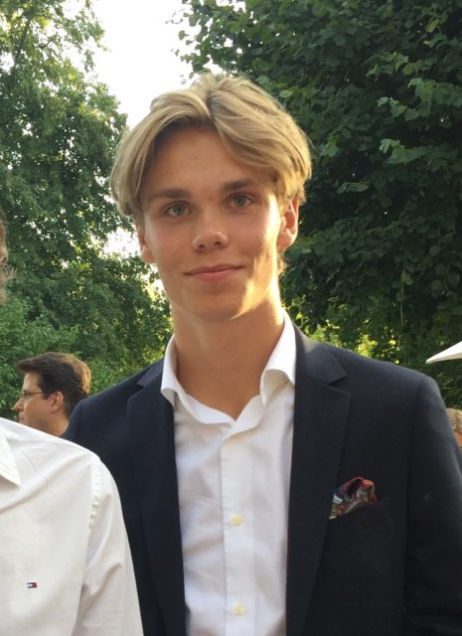
Dear Delegates,
My name is Axel Vide and this fall in Denmark I will be the Committee President for the committee of ITRE (Committee on Industry, Technology, Research and Energy). I live in the beautiful capital of Sweden that we all know as Stockholm and when I’m not working with MEP I’m in the beginning of the third and final year of the economics program. In my freetime I play football in a local team. I also follow both Swedish, European and international politics with great interest! In the fall of 2017 I was a delegate at MEP BSR Riga and having had a great time there, I am so excited to do it again! The question of how economy and technology can be combined with an eco-friendly way of using it will be a very important question coming forward and in the future. Together with you and the other delegates of ITRE, I hope to discuss, learn and develop new ideas as we work towards the end goal, our resolution!

This is the question we will be working with:
The question of climate change and circular economy. At the UN Climate Summit held in Paris in 2015, all participating countries signed to do whatever is in their power to limit global warming. Considering this commitment, what can be done in the EU to enforce and achieve common goals? Should the EU take measures to overcome the lack of cooperation between EU-member states, or should it set its members free to choose to prioritize economic growth over climate change to challenge the competition from the US and Asia?

This committee has perhaps one of the most difficult questions of our time. It would be an understatement to say that the issue is difficult. We as a committee need to set out a plan for the EU and how the European Union in the best possible way can achieve the goals that were made in Paris at the climate conference. We need to decide how much freedom individual countries can have and also how the rest of the world can effect and change our habits. I urge you all to do thorough research so that you gain several perspectives and a broad view on our issue. The most important thing MEP has taught me for future sessions is how important teamwork is, and how much it matters that all delegates feel comfortable enough to come with contributions. Remember that taking on this challenge will not only benefit cooperation and your performance in the General Assembly, but also help you grow as a student, delegate, and committee. If you have any questions, please do not hesitate to contact me by email: axel.vide-2019@vrg.se

Best Wishes,
Axel Vide
Committee President of ITRE

The following links will hopefully give you an understanding of what the agreement is and the challenges it faces going into the future, for example the US withdrawal.
https://www.telegraph.co.uk/business/0/paris-agreement-climate-change-everything-need-know/
https://www.theatlantic.com/science/archive/2017/11/syria-is-joining-the-paris-agreement-now-what/545261/

