Model European Parliament
Baltic Sea Region
Sønderborg, Denmark
Oct 2-7, 2018
Draft PROGRAM

May 2018

MEP BSR Session in Sønderborg, Denmark
Tuesday, October 2nd

Before 18.00 Arrival of the delegations
Pick up by guides and transfer to
Alssundgymnasiet Sønderborg
Grundtvigs Allé 86
6400 Sønderborg
Telefon: 74 42 05 01
www.ags.dk

Contact person: Jens Verdoner

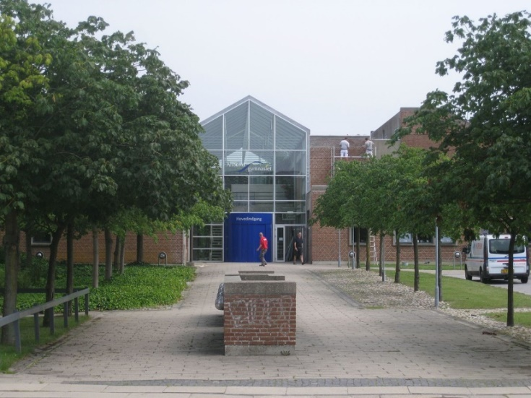

Host families pick up their guests at Alssundgymnasiet
Evening Delegates have dinner and spend evening with their host families

Teachers/Directors stay at Hotel 6400, Solglimt 6, DK 6400 Sønderborg https://www.hotel6400.dk/en/
or at Sønderborg Vollerup Danhostel
www.danhostel-sonderborg-vollerup.dk

20.00 Dinner and welcome briefing for teachers/directors

Wednesday, October 3rd

09:00-10:00 Opening Ceremony at Sønderborg Castle

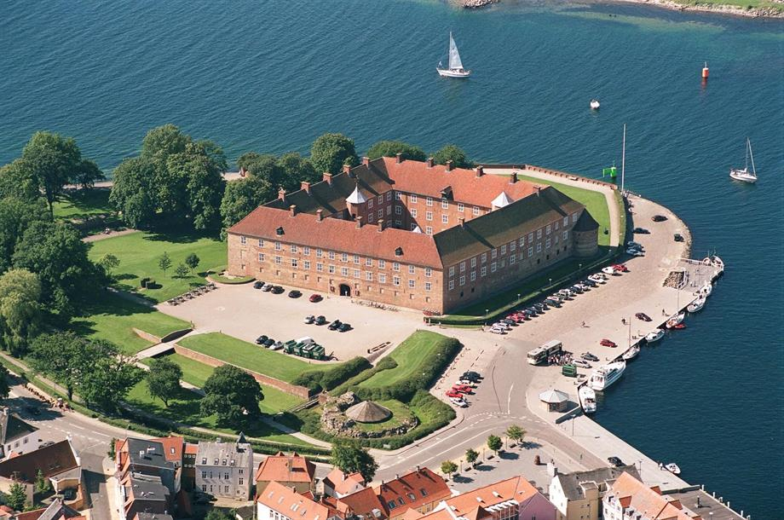

Delegates and teachers/directors have to be present at 08:30

Speakers:

- Mr. Dan Gustafsson, Chairman of the Board of MEP BSR
- Mr. Erik Lauritzen, Mayor of Sønderborg
- Heads of Delegations
- Introduction to CPs by Presidents Simon Ulvsgaard and Maria Buhl Christensen

11.00-12.00 Team Building Activities

12.00-13.00 Lunch

13.00-18.00 Committee Meetings at Alssundgymnasiet

14.00-16.00 MEP BSR Board Meeting for Teachers/Directors
Location: Alssundgymnasiet

Evening Delegates have dinner with host families

Teachers/Directors have dinner on their own account

Thursday, October 4th

09.00-16.00 Committee Meetings continued at Alssundgymnasiet

Resolutions to be handed in at 16.00

16.00-18.00 Correction Panel, printing of resolutions

19.30-21.00 Buffet and Cultural Evening (venue tbc)

Friday, October 5th

10.00-12.30 Lobbying and Delegation Meetings in the center of Sønderborg

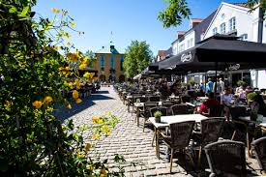

12.00-13.00 Lunch

13.00-16.00 Excursion at Als and Dybbøl

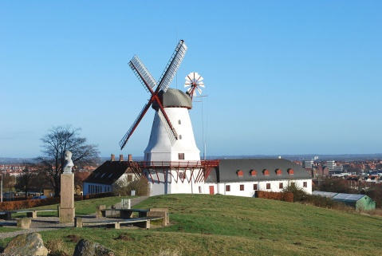

Evening Delegates have dinner with host families
Teachers/Directors have dinner on their own account

Saturday, October 6th

09.30 General Assembly at
SDU/Alsion (tbc)
www.sdu.dk

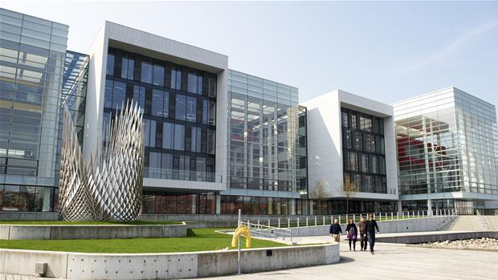

Delegates and Teachers/Directors must be present at 08.30

Speakers:

- Mr/Ms

10.00 Three resolutions in the morning

12.30-13.30 Lunch

13.30-17.00 Three resolutions in the afternoon (coffee break in between)

17.00-17.30 Closing Ceremony

Speakers:
- Presidents of the GA
- Ms. Nina Nørgaard, Administrative Coordinator of MEP BSR

18.00-20.00 Farewell party and buffet.

Sunday, October 7th

Departure all delegations

www.mepbsr.org

