Model European Parliament
Baltic Sea Region
Sønderborg, Denmark
Oct 2-7, 2018
Draft PROGRAM

April, 2018 tbc

MEP BSR Session in Sønderborg, Denmark
Tuesday, October 2nd

Before 18.00 Arrival of the delegations
Pick up by guides and transfer to
Alssundgymnasiet Sønderborg
Grundtvigs Allé 86
6400 Sønderborg
Telefon: 74 42 05 01
www.ags.dk

Contact person:

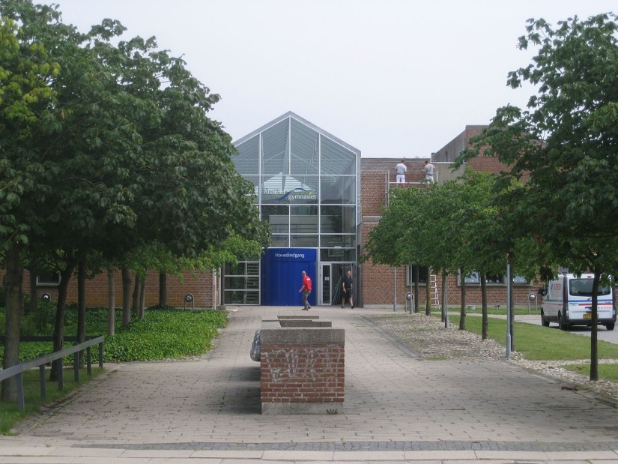

Host families pick up their guests at Alssundgymnasiet
Evening Delegates have dinner and spend evening with their host families

Teachers/Directors stay at Hotel

20.00 Dinner and welcome briefing for teachers/directors

Wednesday, October 3rd

09:00-10:00 Opening Ceremony at Sønderborg Castle (tbc)

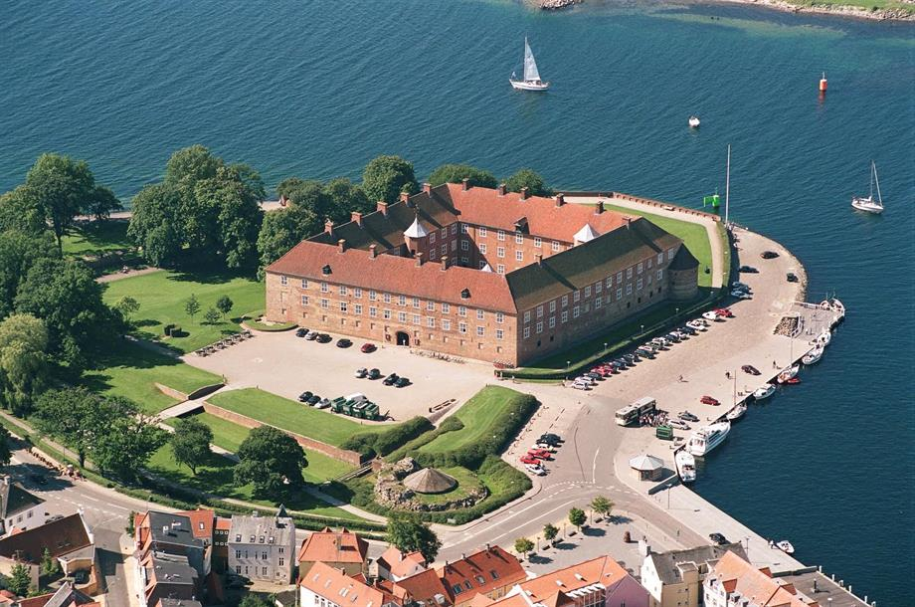

Delegates and teachers/directors have to be present at 08:30

Speakers:

- Mr. Dan Gustafsson, Chairman of the Board of MEP BSR
- Ms/Mr. ……..
- Heads of Delegations

11.00-12.00 Team Building Activities

12.00-13.00 Lunch

13.00-18.00 Committee Meetings at Alssundgymnasiet

14.00-16.00 MEP BSR Board Meeting for Teachers/Directors
Location: (tbc)

Evening Delegates have dinner with host families

Teachers/Directors have dinner on their own account

Thursday, October 5th

09.00-16.00 Committee Meetings continued at Alssundgymnasiet

Resolutions to be handed in at 16.00

16.00-18.00 Correction Panel, printing of resolutions

19.30-21.00 Dinner and Cultural Evening (venue tbc)

Friday, October 6th

10.00-12.30 Lobbying and Delegation Meetings in the center of Sønderborg

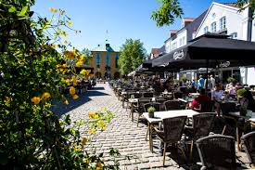

12.00-13.00 Lunch

13.00-16.00 Excursion at Als and Dybbøl

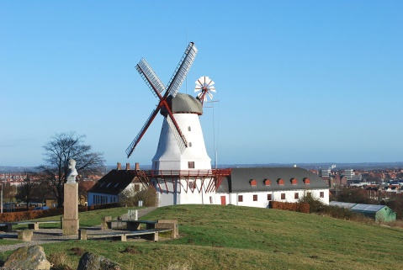

Evening Delegates have dinner with host families

Teachers/Directors have dinner on their own account

Saturday, October 6th

09.30 General Assembly at
SDU/Alsion (tbc)
www.sdu.dk

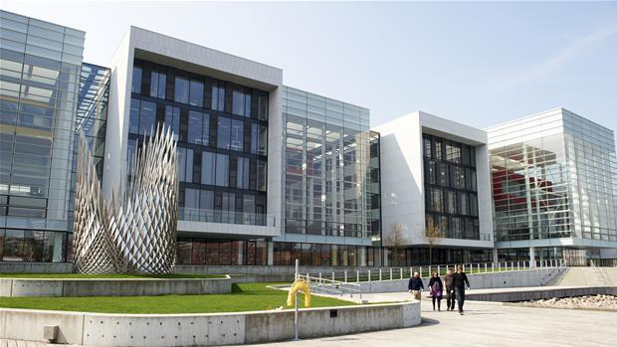

Delegates and Teachers/Directors must be present at 08.30

Speaker:

- Mr/Ms

10.00 Three resolutions in the morning

12.30-13.30 Lunch

13.30-17.00 Three resolutions in the afternoon (coffee break in between)

17.00-17.30 Closing Ceremony

Speakers:
- Presidents of the GA
- Ms. Nina Nørgaard, Administrative Coordinator of MEP BSR

18.00-20.00 Farewell party and buffet.

Sunday, October 8th

Departure all delegations

www.mepbsr.org

