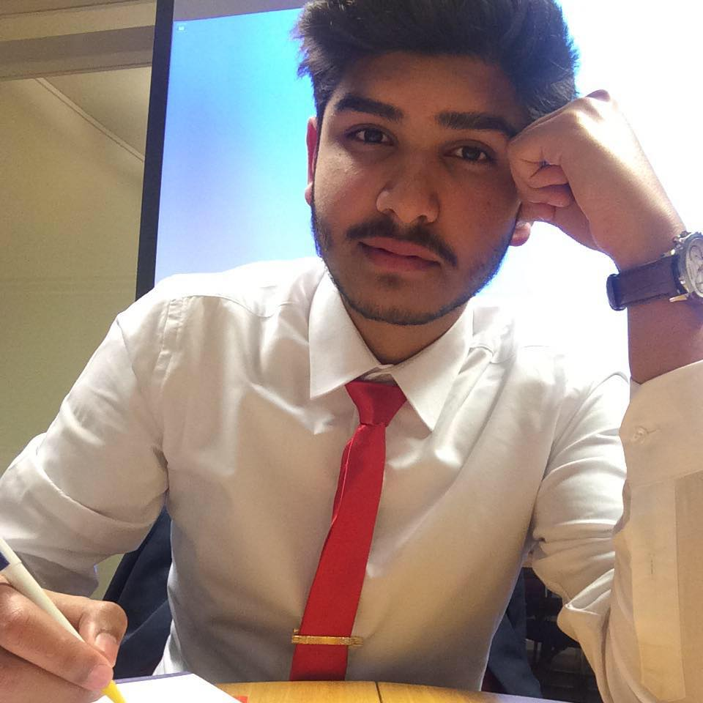
Respectable delegates
I am honoured to welcome you to my committee Culture and Education and I very much look forward to meet every single one of you in Iława, Poland. My name is Sunny S. Ghani and I will be 18 years old when we meet. I study math and science and live in a small city called Halen in Belgium.
Politics has always been one of my biggest passions, that’s why MEP is like a battlefield for my inner gladiator, a place where I feel like nowhere else. I also admire the fact that we get to know so many people from different countries with different cultures.

Let’s get to work, these are the issues we will be discussing in our committee:
- Do the present models of education meet the needs of information technology societies?
- What can be done to produce both technologically and socially aware graduates?
- How can we prepare the society for threats arising from the development of the information
technology like manipulation or fake news?
We will not only be arguing about these points, we will try to find solutions for the present problems, solutions that will be beneficial for the entire EU and the people of the EU. Our issue is a very necessary and important point, the culture and the education of a region are one of the most important points considering the growth on many fields. It will not always be easy to come to a solution. Teamwork, concentration and enough knowledge will be needed, so I strongly recommend to do a lot of research on the issue. I will leave two links that will help you start your research.
I am sure MEP will be an experience that will help you a lot in your lives. It will provide knowledge, it will be positive for your self-esteem and it will be good for your student life.
If you have any kind of questions, you may contact me on my email: sunnyghani8@gmail.com

You’ll do great, and see you all in Poland.
Sunny S. Ghani
Committee President of Culture and Education (CULT)
- http://www.europarl.europa.eu/committees/nl/cult/home.html
Translate the page to English by using the button left on top of the page and search for your information in the different compartments.
- http://www.europarl.europa.eu/RegData/etudes/PERI/2017/600418/IPOL_PERI(2017)600418_EN.pdf
You can find the different topics on the left side of the page, it will be easier to find your information that way.

