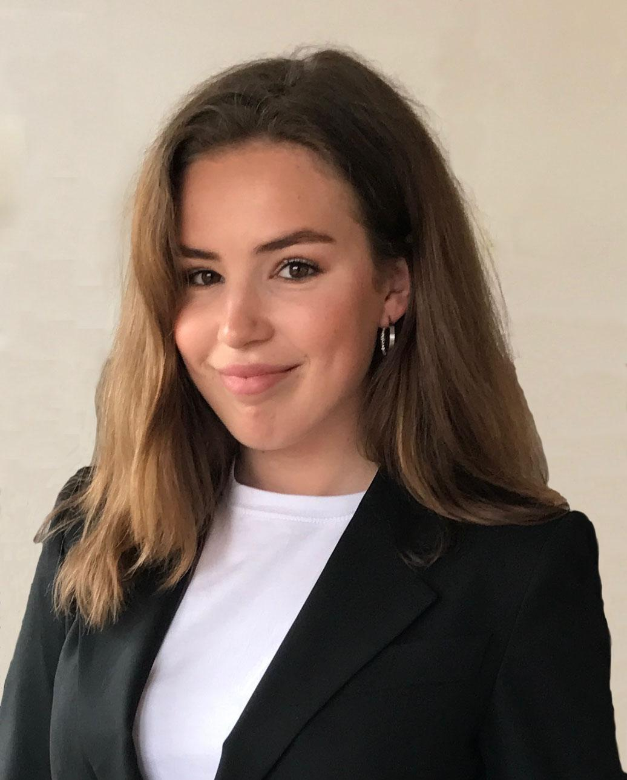
Honorable delegates,

Congratulations on being part of this great experience. My name is Hedda Hövel and I am excited to inform you that I will be your committee president in the MEP BSR Iława session 2018. I am 18 years old and currently in my second year of high school at Viktor Rydberg Djursholm outside of Stockholm, the beautiful capital of Sweden.

Being a member of the committee on Security and Defense means trying to come up with diplomatic solutions to some of the major threats facing our region. The European Union is an establishment with 28 countries who all depend on the union for unity. Support is provided through methods such as the cohesion policy. However, military support is also of essence. Should the next step, in order to further strengthen the union, be to strive towards an independent military alliance such as PESCO? Or is the best solution to opt for NATO and join the 22 EU member states already part of the organization?

The following links are to provide you with basic information on the topic but I also strongly encourage you to do your own research. Being well informed is a vital step towards creating a good resolution and it also makes the committee work more enjoyable.

https://www.nato.int/cps/en/natohq/topics_49217.htm

https://eeas.europa.eu/headquarters/headquarters-homepage_en/34226/Permanent%20Structured%20Cooperation%20(PESCO)%20-%20Factsheet

Do not hesitate to contact me if you have any questions: hedd.hove-2019@vrg.se

I look forward to meeting and getting to know you all!

