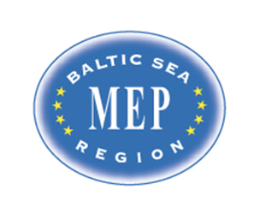

Model European Parliament
Baltic Sea Region
Iława, Poland
April 10-15, 2018
Draft PROGRAM
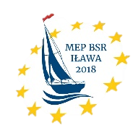
#MEPBSRILAWA
Programme
Tuesday, April 10

Before 15.00 Arrival at the airport of Gdańsk or Warsaw (transport to Iława to be confirmed)
18.00 Pick up by host families or guides to dormitories at
The Secondary School of General Education in Iława (host school)
(Zespół Szkół Ogólnokształcących im. S. Żeromskiego w Iławie)
ul. Sienkiewicza 1, 14-200 Iława
www.zsog.ilawa.pl
www.facebook.com/mepbsrilawa

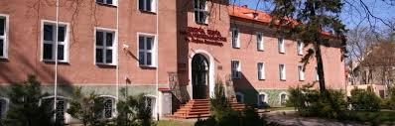

The Secondary School of Technical Education in Iława
(Zespół Szkół im. Bohaterów Września 1939 r.)
ul. Kopernika 8a, 14-200 Iława
http://www.zsilawa.pl

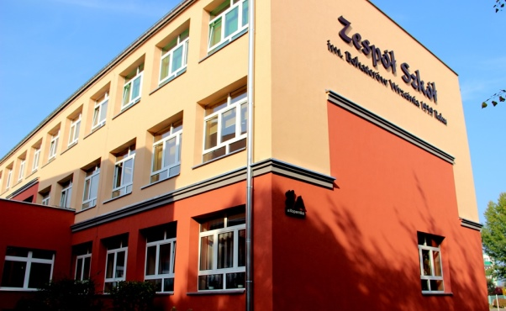

Teachers check into the Stary Tartak Hotel
http://www.starytartak.com.pl/en

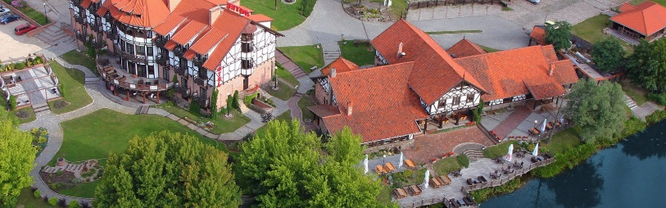

Evening Delegates have dinner and spend evening with their host families
Delegates in the dormitories have dinner together
20.00-21.00 Dinner and welcome briefing for teachers/directors in the hotel
Wednesday, April 11

10.00-12.00 Opening Ceremony
Office of the Poviat Starosty (Starostwo Powiatowe)
ul. Andersa 2a
14-200 Iława
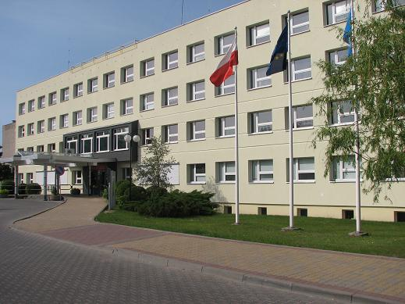

Delegates and teachers have to be present at 9.30
Speakers:
- Mr Dan Gustafsson, Chairman of the Board of MEP BSR
- (tbc)
- Heads of Delegations/Presentations

12.00-12.30 Coffee break

12.30-13.30 Teambuilding activities at the host school

13.30-14.30 Lunch (place tbc)

14.30-18.00 Committee Meetings at
1. Office of the Poviat Starosty in Iława (Starostwo Powiatowe)
2. Inland port in Iława (Port śródlądowy)
3. Host school

15.00-17.00 MEP BSR Board Meeting for Teachers/Directors at the host school/hotel (tbc)

Evening Delegates have dinner with the host families or in the dormitories

Teachers/directors have dinner on their own account

Thursday, April 12

08.30-13.00 Committee meetings continued

13.00-14.00 Lunch included (place tbc)

14.00-17.00 Committee meetings continued

Resolutions to be handed in at 17.00

17.00-18.30 Correction panel, printing at the host school

19.00-22.00 Dinner and Cultural Evening at the host school

Friday April 13

10.00-12.00 Delegation Meetings (place tbc)

12.30-14.00 Lobbying (place tbc)

14.00-15.00 Lunch (place tbc)

Afternoon Guided tour

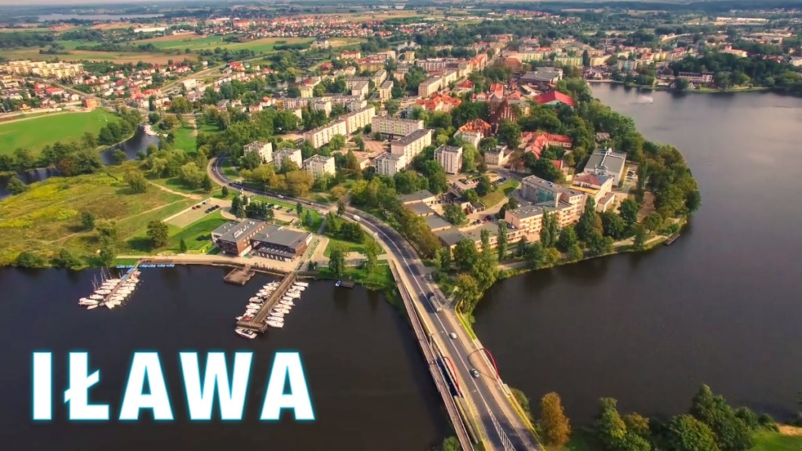

https://www.youtube.com/watch?v=_gF_w6cGSJg

Handing in amendments and textual changes
Evening Students and Teachers/Directors have dinner on their own account

Saturday April 14

09.00 General Assembly
Office of the Poviat Starosty (Starostwo Powiatowe)
ul. Andersa 2a
14-200 Iława
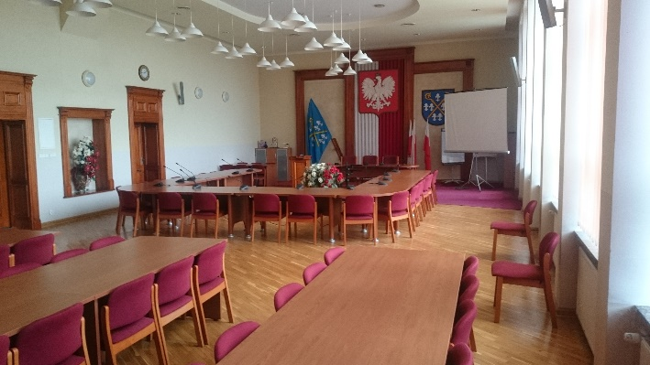
Delegates and teachers have to present at 8.30.

Speakers (to be confirmed)
- Mr.
- Ms.

9.30 Three resolutions in the morning

13.00 Lunch

14.00 General Assembly continued
Two resolutions in the afternoon

16.30-17.00 Closing Ceremony

Speakers:
- Ms./Mr. President of the General Assembly
- Ms. Nina Nørgaard, Administrative Coordinator of MEP BSR

19.00-21.30 Farewell party and dinner at the host school

Sunday April 15
Departure all delegations
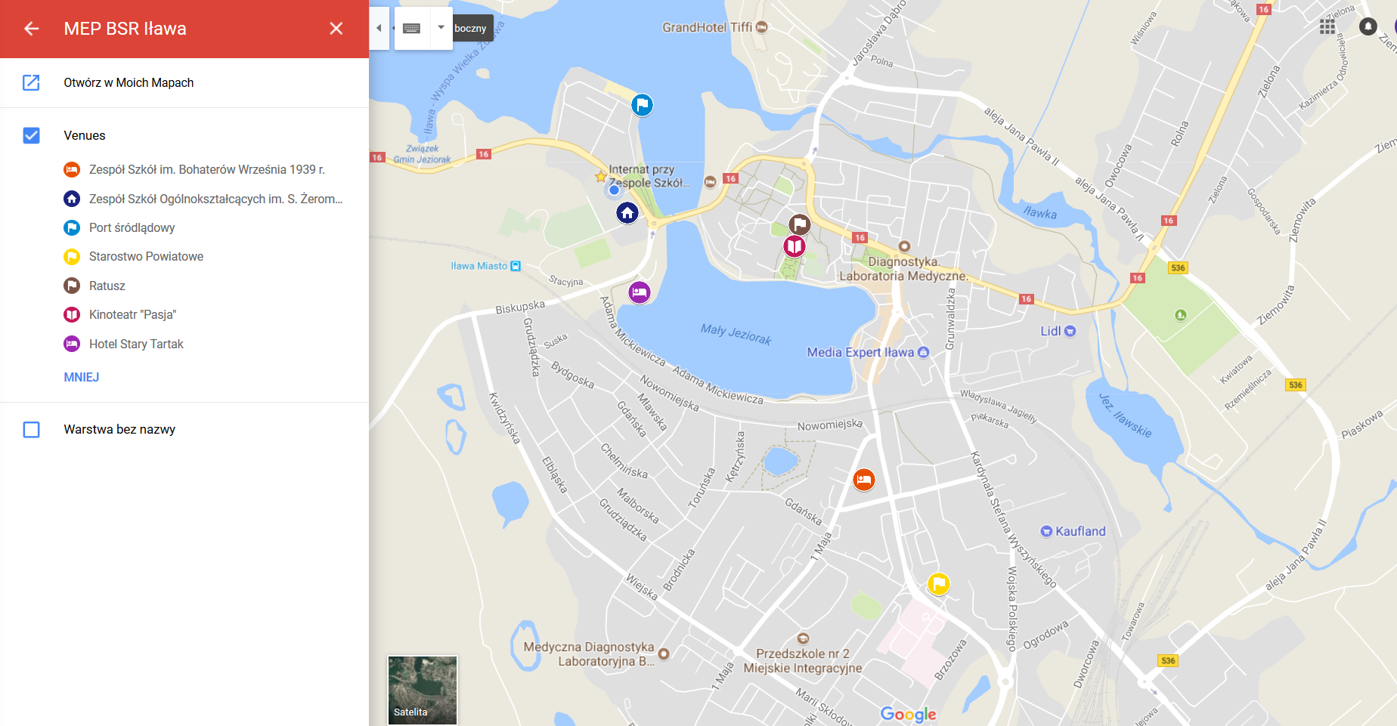

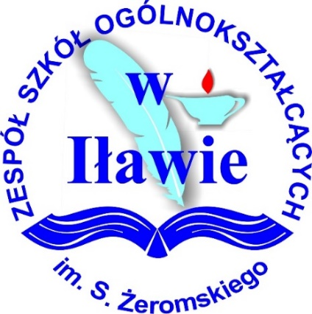

www.mepbsr.org

