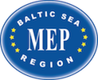

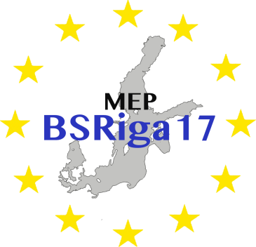

Model European Parliament
Baltic Sea Region
Riga, Latvia
Oct 3-8, 2017
PROGRAM

MEP BSR Session in Riga, Latvia

Tuesday, October 3rd

Before 18.00 Arrival of the delegations at Riga Airport or Riga
Coach Station
Pick up by guides and transfer to international school of Riga to meet host families:

International School of Riga
Zvejnieku iela 12
Kurzemes rajons, Riga, LV-1048
www.isriga.lv

Or pick up by guides and transfer to hostels:

Cinnamon Sally Backpackers Hostel
Merķeļa iela 1, 3rd floor, Rīga, LV-1050
www.cinnamonsally.com

Riga Hostel
Merķeļa iela 1, 4th floor, Rīga, LV-1050
www.rigahostel.com.lv

Teachers check in to hotel:

Astor Riga
Z.A.Meierovica Blvd. 10
Riga, LV-1050, Latvia
http://www.astorrigahotel.lv/

Evening Delegates have dinner and spend evening with their host families

Delegates in hostel have dinner together (tba)

20.00-21.00 Dinner and welcome briefing for teachers/directors

Wednesday, October 4th

10:00-12:00 Opening Ceremony at:

Maza Gilde/The Grand Hall
Amatu iela 3
Centra rajons, Riga, LV-1050

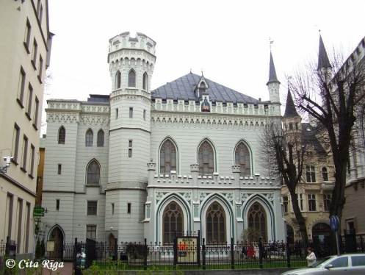

Delegates and teachers/directors have to be present at 09:30

Speakers:

- Mr Dan Gustafsson, Chairman of the Board of MEP BSR
- Mr Kieran Nolan, The International School of Riga
- Ms Lolita Cigane, Chair European Affairs Committee, Member of the Latvian Parliament
- Heads of Delegations

Coffee break

12.00 Leaving to:

Stockholm School of Economics in Riga
Strēlnieku iela 4A
Centra rajons
Rīga, LV-1010

Riga Graduate School of Law
Strēlnieku iela 4 k-2
Centra rajons
Rīga, LV-1010

12.30-13.00 Short intro from the Universities

13.00-14.00 Lunch

14.00-18.00 Committee Meetings after Team-building activities

15.00-17.00 MEP BSR Board Meeting for Teachers/Directors at

Albert Hotel
Dzirnavu iela 33
Rīga, LV-1010
www.alberthotel.lv

Evening Delegates have dinner with host families

Delegates in hostel have dinner together (tba)

Teachers/Directors have dinner on their own account

Thursday, October 5th

8.30-12.30 Committee Meetings continued

12.30-13.30 Lunch

13.30-16.00 Committee Meetings continued

Resolutions to be handed in at 16.00

16.00-18.00 Correction Panel, printing of resolutions

19.00-22.00 Dinner and Cultural Evening at International School of Riga

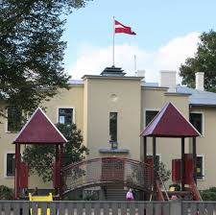

Friday, October 6th

10.00-11.30 National delegation meetings and lobbying at

Astor Riga
Z.A.Meierovica Blvd. 10
Riga, LV-1050

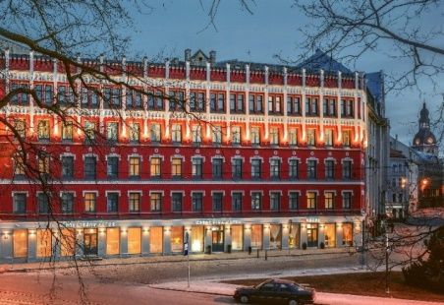

12.00-13.00 Lunch at Astor Riga

13.00-16.00 Guided tour of Riga

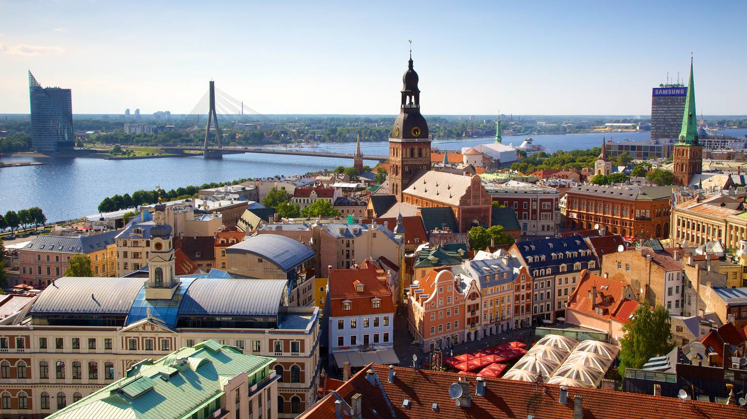

Evening Students and teachers have dinner on their own account.

Saturday, October 7th

0.9.00 General Assembly at

University of Latvia, Lielā aula
Raiņa bulvāris 19, Centra rajons, Rīga, LV-1586
www.lu.lv

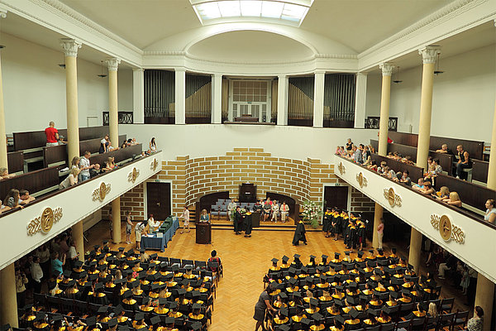

Delegates and Teachers/Directors must be present at 08.30

Speaker:

- H.E. Ambassador Hans Brask, Danish Embassy in Latvia

09.30-12.30 Three resolutions in the morning

12.30-13.30 Lunch at Čili Pizza

13.30-16.30 Three resolutions in the afternoon

16.30-17.00 Closing Ceremony

Speakers:
- President of the GA/Astrid Ytre-Eide
- Ms. Nina Nørgaard, Administrative Coordinator of MEP BSR

19.00-21.30 Farewell party and dinner.

Restaurant “Čarlstons” Banquet Hall
Blaumaņa street 38/40, Riga, LV-1011

Sunday, October 8th

Departure all delegations

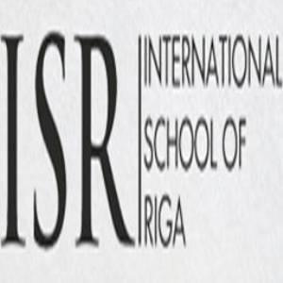

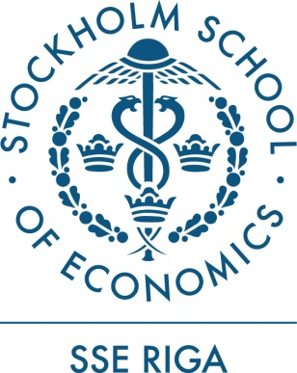

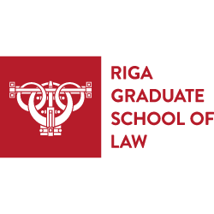

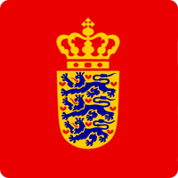

Embassy of Denmark in Latvia

www.mepbsr.org

