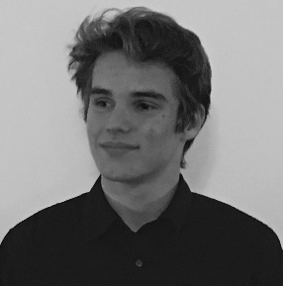
Dear Members of the Committee on Civil Liberties, Justice and Home Affairs

First of all, let me welcome all of you to the MEP Baltic Sea Region 2017. Congratulations on being part of this unique experience and on being part of our committee.
My name is Simon Becke, I am from Austria and I am very much looking forward to chairing the committee on Civil Liberties, Justice and Home Affairs in this year´s MEP BSR in Riga. And of course I am most of all looking forward to meeting all of you and to hearing many interesting and yet diverse opinions on our very challenging however essential topic for the future of the European Union.
In the committee meetings we will deal with the following issue:
The question of immigration. With the rapid influx of refugees, asylum seekers and immigrants into Europe what measures can be taken to attempt an even distribution between countries, and to ensure integration amongst the various groups. To what extent should cultural diversity and religions be accepted when they might conflict with national practices and legislation.
Due to several different contemporary political events in the last two years, this topic has been one of great public and political attention, yet no European solution could be found in the course of all attempts by European politicians. This offers you the unique chance of dealing with a very essential issue and you can attempt to find potential solutions for an issue, which is in the focus of contemporary politics.
Mayhap, you can come up with ideas which were not yet presented by and European Politician or you can demonstrate that multilateral solutions can be found, although the current political situations show something else.
Due to many different reasons I am personally convinced that the topic we will be dealing with, is one of the most decisive ones for the future of the European Union – solving this relevant issue can prove European unity, cooperation and solidarity and however, on the other hand can demonstrate the unwillingness of some member states to agree upon collective solutions and decisions.
I am very much looking forward to your diverse opinions on this topic, since every one of you may have made different experiences with this topic resulting in many different approaches to the issue.
Yet, I am convinced that all of you will be more than willing to find a common solution and I am more than certain that you will prove Europe´s solidarity and unity and will demonstrate that the European Union can show multilateral cooperation, despite representing many different opinions.
I am very much looking forward to meeting all of you in October!
Best regards and see all of you in Riga,
Simon Becke
Committee President of the committee LIBE

Links:
https://www.weforum.org/agenda/2016/05/10-ways-countries-can-help-refugees-integrate/
http://archive.intereconomics.eu/year/2016/4/on-the-distribution-of-refugees-in-the-eu/

