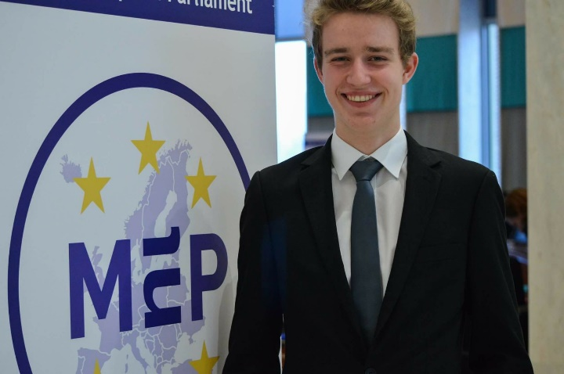
Dear delegates,
Congratulations on making it to MEP BSR Riga! It will be a fantastic experience to meet other young people from the whole Baltic Sea Region, spend a week together and discuss the most pressing issues of the EU.
I am Georg Maxton and have the honor to chair the Committee on Industry, Research and Energy. I am excited to me all of you on October and work on Climate Change, a problem becoming more important with each passing day.
Unfortunately German Chancellor Merkel has been proven to be right when she said: “The times in which we could rely fully on others – they are somewhat over.” Donald Trump will withdraw the United States of America from the Paris Climate Agreement!
As much as this decision of the current President disappoints me am I looking forward to work together with all of you on a solution for maybe the most pressing issue of our time. Creativity, innovation and fresh ideas have never been more needed then now and I cannot wait to see and hear from your approach to climate change. Which are the energy sources we should build our internal energy market on? And how do we ensure a smooth transition to those energy sources?
And most importantly in order to step up to the challenge of the implementation of the Paris Agreement even without the full support of the United States of America: How can we work together even closer and more effective?
If you have any questions concerning our work on the committee feel free to contact me.
All the best
Georg Maxton, CP
g.maxton@web.de

For preparation I would like to ask you to read the following articles. They contain information about the internal energy market and the current EU policy on climate change. This will be absolutely crucial knowledge for our work in the committee. I also encourage you to do some research going beyond the articles I provided you with. I am looking forward to see you soon!
The internal energy market:
http://www.europarl.europa.eu/atyourservice/en/displayFtu.html?ftuId=FTU_5.7.2.html
EU climate action:
https://ec.europa.eu/clima/citizens/eu_en

