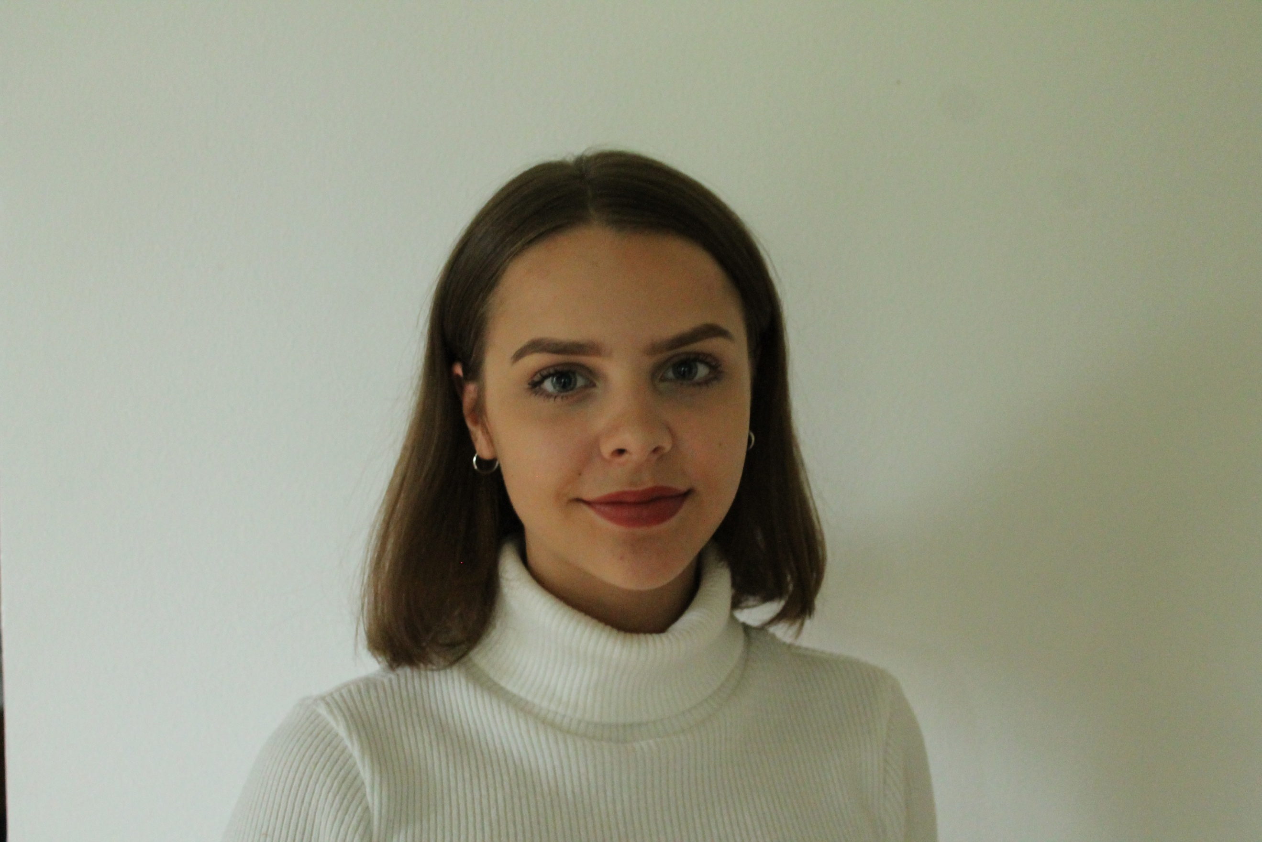
Dear Delegates,

My name is Taimi Vilkko, and I will be the Committee President for committee on Employment and Social Affairs.

I’m 17 years old, and I live in Helsinki, Finland. I’m a second year high school student, and the school I go to specializes in languages. Through my school I’ve had the opportunity to take part in many international events, such as MEP. I’m highly interested in national and international politics, the European Union, and being able to make an impact on society.

So far, I have attended two MEP sessions; an international MEP session in The Netherlands in 2017 as a delegate, and a national session in Finland as a committee president.

I believe the MEP is a great opportunity for the youth of Europe to learn about politics, decision making, and internationality. It is a platform to share your ideas about relevant issues concerning the EU, to challenge yourself and others to debate the issues, and to team up with new friends from all over Europe in search for the best solutions.

Our committee issue, the question of youth employment, is obviously very relevant in the EU today. The youth unemployment rate is alarming in various EU countries, and the development of labour mobility is one key element to tackle this issue. The question “How can mobility of employment-seeking young EU citizens be promoted and should they be entitled to the same allowances and social benefits as young citizens of the respective countries? How can mobility measures counteract large scale youth unemployment in Europe without draining the social system of another EU country?” is definitely a complex one, but I’m sure we will have no trouble in finding profound answers.

Proper preparation is the key for having insightful discussions and fruitful debates. With the sufficient amount of preparation, you will be able to bring the best ideas and solutions to the table. I advise all of you to prepare thoroughly for the session; read the articles carefully and make sure to do some independent research as well, to ensure every committee member’s equal contribution to and participation in the committee work.

I look forward to guiding you through the committee work, and I’m sure we will make a great team and have a good time together. I wish you all a wonderful MEP experience!

If you have any questions, please do not hesitate to contact me.

taimivilkko@gmail.com

http://ec.europa.eu/eurostat/statistics-explained/index.php/Youth_unemployment

http://www.institutdelors.eu/media/labourmobilityeuroarea-brinkedittrich-jdib-mar16.pdf?pdf=ok

