

**Model European Parliament Baltic Sea Region**

**Kaliningrad, Russia, Oct 3-8, 2016**

**Monday October 3**

Before 16.00 Arrival of delegates and teachers/directors at

Gymnasium №40 named after U. Gagarin

Matochkina 4, Kaliningrad,

<http://gym40.ru/>

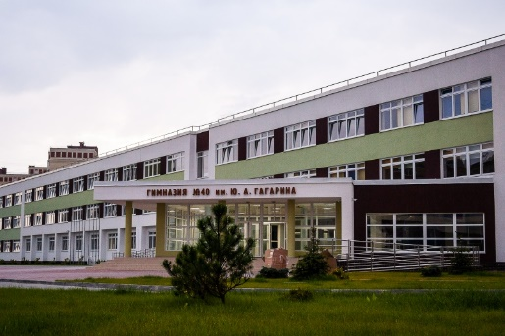 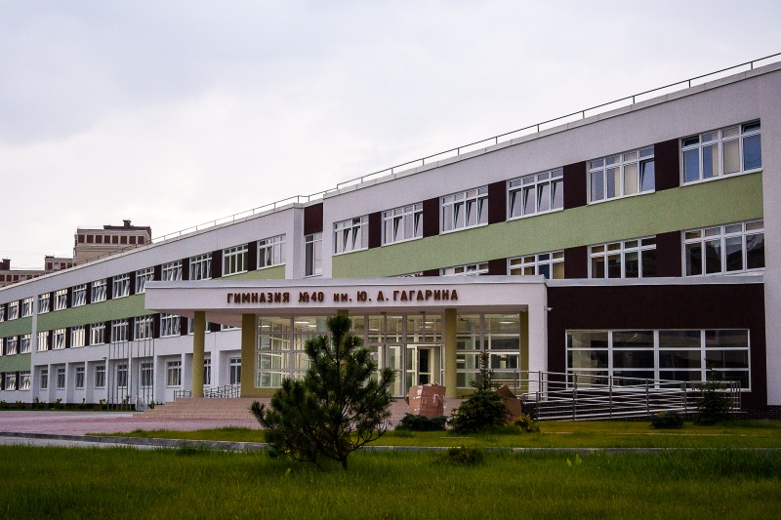

16.00 Registration of delegates and teachers

17.00 Teambuilding for delegates

19.00 Host parents pick up delegates at the Gymnasium.

Dinner with host families / dinner at the Gymnasium (for delegates who stay at the hostel)

Teachers/directors stay in ____________ 



20.00 Dinner for teachers/directors at the Restaurant

**Tuesday October 4**

09.00-11.00 Opening Ceremony at the Ministry of Foreign Affairs Hall, Kirova 17, Kaliningrad,

<http://kaliningrad.mid.ru/>

Delegates and teachers have to be present at 8.30

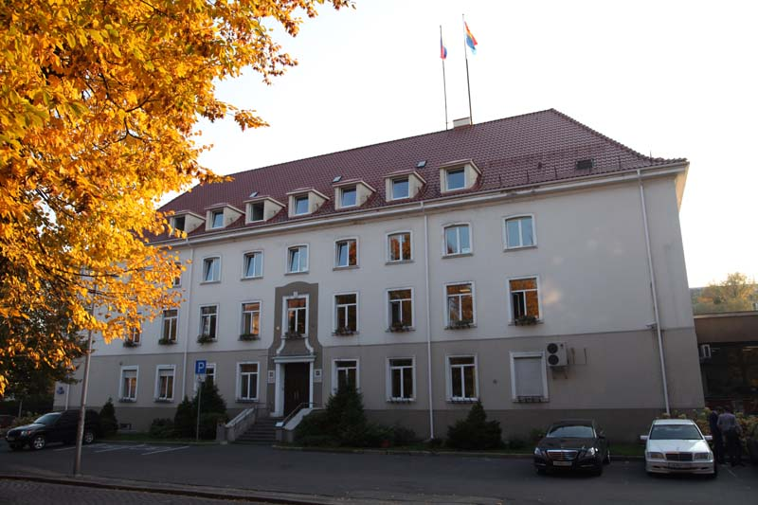

Speakers:

* Mamontov Pavel, The Main Representative of the Ministry of Foreign Affairs;
* Heads of Delegations

11.00-12.00 Teambuilding (town quest)

12.00-13.00 Lunch in committees at Gymnasium №40

13.00-18.00 Committee meetings at Gymnasium №40

13.30-14.00 Short excursion around the building for teachers (acquaintance with infrastructure and technical equipment)

14.00-15.30 MEP BSR Board Meeting for teachers/directors at Gymnasium №40

Dinner with host families / dinner at the Gymnasium (for delegates who stay at the hostel)

Teachers go to Svetlogorsk to have dinner there

**Wednesday October 5**

09.00-12.00 Committee meetings continued at Gymnasium №40

12.00-13.00 Lunch at school

13.00-16.00 Committee meetings continued

16.00 Resolutions to be handed in 16.00

16.30-17.00 Dinner at the Gymnasium (for delegates who stay at the hostel)

16.00-18.00 Correction panel, printing, Gymnasium №40

19.00-20.00 Sport competition (badminton, swimming, volleyball)

Teachers go to the Curonian Spit

**Thursday October 6**

09.00-12.00 Delegation Meetings and lobbying at the Museum of the World Ocean,

Naberezhnaya Petra Velikogo 1, Kaliningrad

<http://world-ocean.ru/ru/>

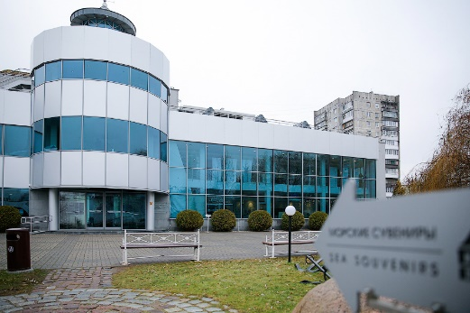

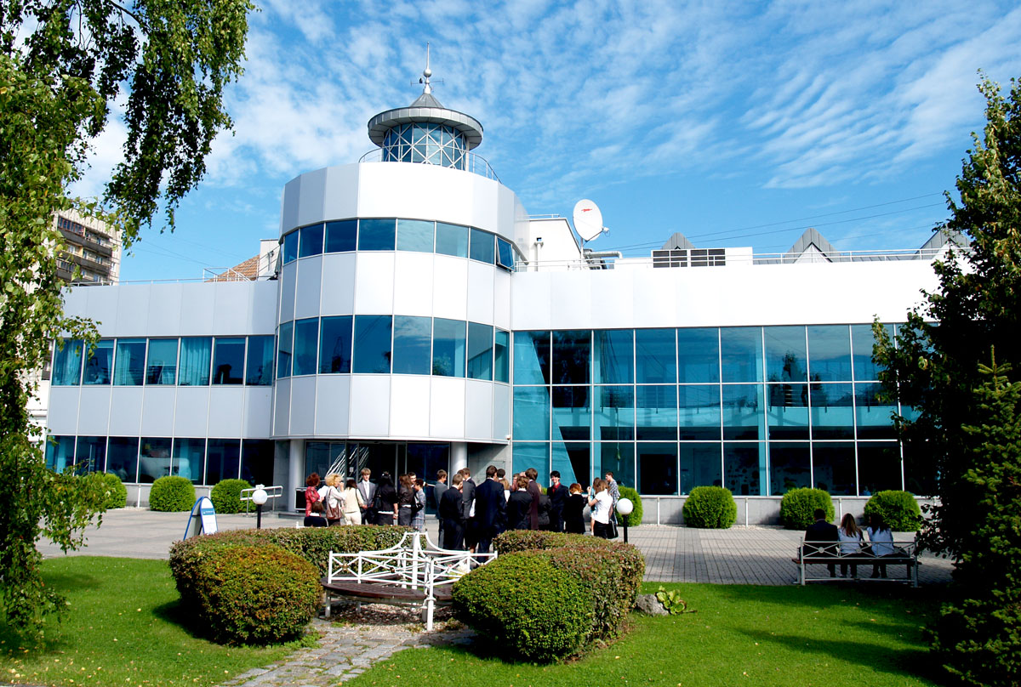

Handing in amendments and textual changes

Guidance and instruction meeting with Committee Presidents

12.00-13.00 Lunch at the Café in the Museum

13.00-16.00 Sightseeing for delegates and teachers/directors

Dinner with host families / dinner at the Gymnasium (for delegates who stay at the hostel)

**Friday October 7**

09.00-17.00 General Assembly at the Regional Duma Hall,

Kirova 17, Kaliningrad



Speakers:

Three resolutions in the morning (Coffee breaks)

Lunch

General Assembly continued

Three resolutions in the afternoon (Coffee breaks)

16.30 Closing Ceremony

Speakers:

* ________________, President of the General Assembly
* Ms. Nina Nørgaard, Administrative Coordinator of MEP BSR

19.00-21.00 Farewell party with dinner

**Saturday October 8**

Departure all delegations

www.mepbsr.org

