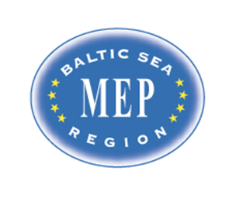

Model European Parliament
Baltic Sea Region
Riga, Latvia, 2016

MEP BSR Session in Riga, Latvia
March 29 – April 3, 2016
Program:

Tuesday March 29

Before 18.00 Arrival of delegates and teachers/directors in Riga
Travel to Hotel Primo. 62 Nometnu street, Riga, LV-1012, Latvia
Phone: +371 25 888 777, www.primohotel.lv
http://www.primohotel.lv/eng/location.php
Here you find direction for Hotel Primo (info below for teachers´ hotel)
Public transport bus No.22: (Airport - Abrenes street). To get on the bus look for bus stop located opposite the terminal behind the car par P1. Frequency 10 – 30 minutes, journey time about 30 minutes. Price – 2.00 euro (directly to bus driver).

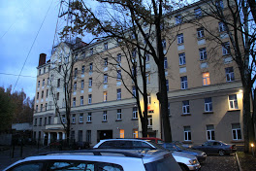

18.00 Registration of delegates /2 teachers
Pizzas
Teachers/directors stay at Hotel Radi Un Draugi,
Mārstaļu iela 3, Rīga, LV-1050
http://hotelradiundraugi.lv/en/

20.00 Dinner for teachers/directors at Hotel Radi Un Draugi

Wednesday March 30

10.00 -11.00 Opening Ceremony at the National Library of Latvia, Mukusalas 3, Riga
www.lnb.lv
Delegates and teachers/directors have to present at 9.30 for security procedures. All participants must bring ID with picture.

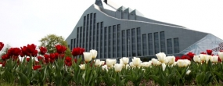

Speakers:
- Mr. Dan Gustafsson, Chairman of the Board of MEP BSR
- Ms Marja Kokare, Headmaster English Grammar School
- Lord Mayor, Riga City Council tbc
- Ms. Lolita Cigane, Chairman European Affairs Committee, Saeima/
Latvian Parliament
- Heads of Delegations/Presentations

11.00 -12.00 Teambuilding/traveling to school/guides: cps and Latvian students

13.00 -14.00 Lunch in committees at The English Grammar School
Zvardes iela 1, Riga, LV-1004, www.rag.lv

14.00 -17.00 Committee meetings at The English Grammar School

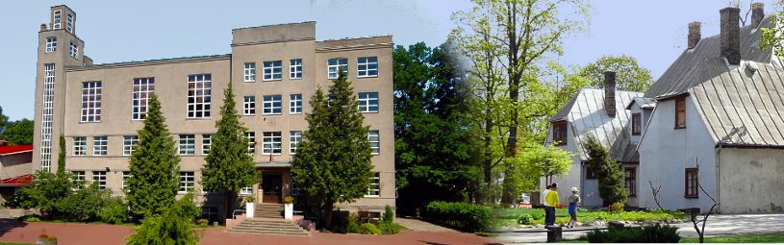

15.00 -17.00 MEP BSR Board Meeting for teachers/directors (location to be announced)

18.00 Dinner for students (and teachers) at Lido AS, Krasta street 76, Riga, LV-1019,

Teachers have dinner on their own account
Thursday March 31

09.00-16.00 Committee meetings continued at The National Library
Resolutions to be handed in at 16.00

12.00 – 13.00 Lunch at NL for delegates

16.00-18.00 Correction panel, printing

18.00 Dinner for students at Lido AS, Krasta street 76, Riga, LV-1019, Latvia

20.00-21.30 Cultural Event/get together in downtown Riga

Friday April 1

09.00-12.00 Delegation Meetings and lobbying at the National Library
Handing in amendments and textual changes
Guidance and instruction meeting with Committee Presidents

Lunch downtown on own account

13.30-15.00 Visit to the Latvian Parliament, Saeima /Meeting time 13.30
www.saeima.lv
All participants must bring ID with picture
Sightseeing in Riga for students and teachers/directors

Free time

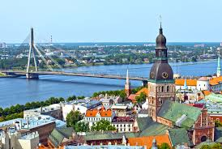

18.00 Dinner for students in groups
19.00 Dinner for teachers/directors (location to be announced)

Saturday April 2

10.30 General Assembly at the National Library of Latvia
3 Mukusalas ilea, Riga, www.lnb.lv
Delegates and teachers have to present at 10.00
All participants must bring ID with picture

Speakers:
- Mr. Jan Widberg, Director, Nordic Council of Ministers Office in Latvia
- Mr. Edwin von Krusenstjerna, President of the GA

10.45 Two resolutions in the morning (coffee break in between)

13.00 Lunch

13.30 General Assembly continued
Three resolutions in the afternoon (coffee breaks in between)

16.30 Closing Ceremony

Speakers:
- President of the General Assembly
- Ms. Nina Nørgaard, Administrative Coordinator of MEP BSR

18.00-20.00 Farewell reception and buffet for all, http://cafedali.eu/
Hosted by Riga City Council

Sunday April 3

Departure all delegations

www.mepbsr.org

Contact numbers:
Hans Lindemann +45 40317753
Nina Nørgaard +45 26201105

