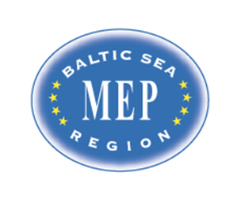

Model European Parliament
Baltic Sea Region
Riga, Latvia, 2016
March 29 – April 3
Draft PROGRAM

MEP BSR Session in Riga, Latvia
March 29 – April 3, 2016

Program:

Tuesday March 29

Before 18.00 Arrival of delegates and teachers/directors in Riga.
Travel to Hotel Primo. 62 Nometnu street, Riga, LV-1012, Latvia
Phone: +371 25 888 777, www.primohotel.lv
Public transport bus No.22: (airport - Abrenes street). To get on the bus look for bus stop located opposite the terminal behind the car par P1. Frequency 10 – 30 minutes, journey time about 30 minutes. Price – 2.00 euro (directly to bus driver).

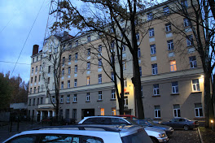

18.00 Registration of delegates and teachers/directors
Teachers/directors stay at Hotel Radi Un Draugi,
Mārstaļu iela 3, Rīga, LV-1050

http://www.hotelradiundraugi.lv/en/

20.00 Dinner for teachers/directors at Hotel Radi Un Draugi

Wednesday March 30

09.30-11.00 Opening Ceremony at the National Library of Latvia, Mukusalas 3, Riga
www.lnb.lv
Delegates and teachers/directors have to present at 9.00 for security procedures. All participants must bring ID with picture.

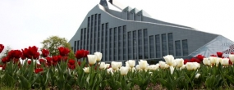

Speakers:
- Mr. Dan Gustafsson, Chairman of the Board of MEP BSR
- Ms. Lolita Cigane, Chairman European Affairs Committee, Saeima/Latvia
- Lord Mayor, Riga City Council tbc
- Ms Marja Kokare, Headmaster English Grammar School tbc
- Heads of Delegations

11.00-12.00 Teambuilding

12.00-13.00 Lunch in committees

14.00-17.00 Committee meetings at English Grammar School

15.00-17.00 MEP BSR Board Meeting for teachers/directors

Dinner for students
Teachers have dinner on their own account

Thursday March 31

09.00-16.00 Committee meetings continued at The National Library
Resolutions to be handed in at 16.00

16.00-18.00 Correction panel, printing.

20.00-21.30 Cultural Event/get together in downtown Riga

Friday April 1

09.00-12.00 Delegation Meetings and lobbying at the National Library
Handing in amendments and textual changes
Guidance and instruction meeting with Committee Presidents
Lunch

14.00-17.00 Sightseeing in Riga for students and teachers/directors
Visit to the Latvian Parliament /Saeima tbc
Free time

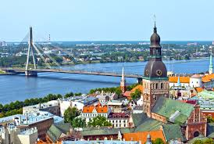

18.00 Dinner for students
19.00 Dinner for teachers/directors (location to be announced)

Saturday April 2

10.30 General Assembly at the National Library of Latvia
3 Mukusalas ilea, Riga, www.lnb.lv

Delegates and teachers have to present at 10.00
All participants must bring ID with picture

Speakers:
- Mr. Hans Brask, the Danish Ambassador to Latvia tbc
- President of the GA

10.45 Two resolutions in the morning (coffee break in between)

13.00 Lunch

13.30 General Assembly continued
Three resolutions in the afternoon (coffee breaks in between)

16.30 Closing Ceremony

Speakers:
- President of the General Assembly
- Ms. Nina Nørgaard, Administrative Coordinator of MEP BSR

18.00-20.00 Farewell reception and buffet (location to be announced)
Hosted by Riga City Council

Sunday April 3

Departure all delegations

Organization:
The MEP BSR Organization in cooperation with the Danish Cultural Institute in Estonia, Latvia and Lithuania

www.mepbsr.org

