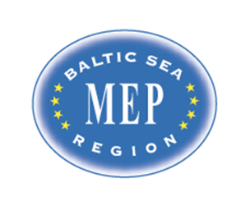

Model European Parliament
Baltic Sea Region
Riga, Latvia, 2016
March 29 – April 3
Draft PROGRAM

MEP BSR Session in Riga, Latvia
March 29 – April 3, 2016

Program:

Tuesday March 29

Before 18.00 Arrival of delegates and teachers/directors in Riga.
Travel to Hotel Primo. 62 Nometnu street, Riga, LV-1012, Latvia
Phone: +371 25 888 777, www.primohotel.lv

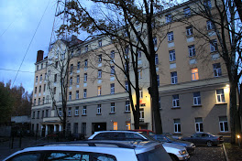

18.00 Registration of delegates and teachers/directors
Teachers/directors stay at http://www.hotelradiundraugi.lv/en/

20.00 Dinner for teachers/directors at (will be announced)

Wednesday March 30

09.30-11.00 Opening Ceremony at the National Library of Latvia, Mukusalas 3, Riga
www.lnb.lv
Delegates and teachers/directors have to present at 8.30 for security procedures. All participants must bring ID with picture.

Speakers:
- Mr. Dan Gustafsson, Chairman of the Board of MEP BSR
- Ms. Lolita Cigane , Chairman European Affairs Committee tbc
- Mr. Simon D. Holmberg, The Danish Cultural Institute tbc
- Ms Marja Kokare, Headmaster English Grammar School tbc
- Heads of Delegations

11.00-12.00 Teambuilding

12.00-13.00 Lunch in committees

13.30-18.00 Committee meetings at English Grammar School tbc

14.00-16.00 MEP BSR Board Meeting for teachers/directors

Dinner for students
Teachers have dinner on their own account

Thursday March 31

09.00-16.00 Committee meetings continued at the English Grammar School tbc
Resolutions to be handed in at 16.00

16.00-18.00 Correction panel, printing.

20.00-21.30 Cultural Event/get together in downtown Riga

Friday April 1

09.00-12.00 Delegation Meetings and lobbying at the National Library
Handing in amendments and textual changes
Guidance and instruction meeting with Committee Presidents
Lunch

12.00-17.00 Sightseeing in Riga for students and teachers/directors
Free time

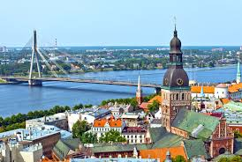

18.00 Dinner for students
19.00 Dinner for teachers/directors (location to be announced)

Saturday April 2

09.00 General Assembly at the National Library of Latvia
3 Mukusalas ilea, Riga, www.lnb.lv

Delegates and teachers have to present at 8.30 due to security procedures. All participants must bring ID with picture

Speakers:
- Mr. Hans Brask, the Danish Ambassador to Latvia tbc
- President of the GA

9.30 Three resolutions in the morning (coffee break in between)

12.00 Lunch

13.00 General Assembly continued
Two resolutions in the afternoon (coffee breaks in between)

16.00 Closing Ceremony

Speakers:
- Ms./Mr. President of the General Assembly
- Ms. Nina Nørgaard, Administrative Coordinator of MEP BSR

18.00-20.00 Farewell party and buffet dinner at (to be announced)

Sunday April 3

Departure all delegations

Organization:
The MEP BSR Organization in cooperation with the Danish Cultural Institute in Estonia, Latvia and Lithuania

www.mepbsr.org

