MEP BSR Session in Oslo, Norway October 6 - 11, 2015
Program:

Tuesday October 6

Before 18.00 Arrival of delegates and teachers/directors at Oslo Airport Gardermoen.
Travel to Nesbru videregående skole (Upper Secondary School)
Halvard Torgersensvei 8, 1378 Nesbru, www.nesbru.vgs.no

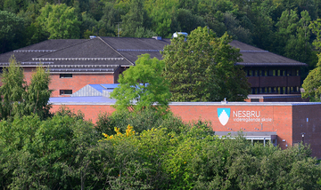

18.00 Registration of delegates and teachers
19.00 Host families pick up delegates at Nesbru. Dinner with host families

Teachers/directors stay in Cochs Pensjonat, Parkveien 25 N, 0350 Oslo, www.cochspensjonat.no

20.00 Dinner for teachers/directors at Restaurant OLYMPEN,
Grønlandsleiret 15, 0190 Oslo.

Wednesday October 7

09.00-11.00 Opening Ceremony at Asker Town Hall, Knud Askers vei 24, 1371 Asker,
www.asker.kommune.no
Delegates and teachers have to be present at 8.30

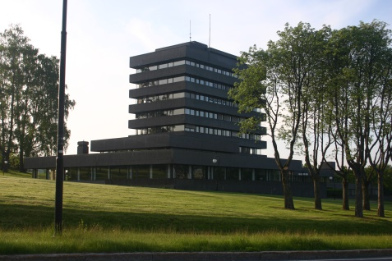

Speakers:
- Ms. Lene Conradi, Mayor of Asker
- Mr. Dan Gustafsson, Chairman of the Board of MEP BSR
- Mr. Knut Gundersen, Nesbru vgs
- Mr. Mathias Holmen Johnsen, former Nesbru-student
- Heads of Delegations

11.00-12.00 Teambuilding

12.00-13.00 Lunch committee wise at Nesbru vgs

13.30-18.00 Committee meetings at Nesbru vgs

14.00-16.00 MEP BSR Board Meeting for teachers/directors at Nesbru vgs

Dinner for students with host families.
Teachers have dinner on their own.

Thursday October 8

09.00-16.00 Committee meetings continued at Nesbru vgs

Resolutions to be handed in at 16.00

16.00-18.00 Correction panel, printing, Nesbru vgs

Dinner for students with host families.
Teachers have dinner on their own.

Friday October 9

09.00-12.00 Delegation Meetings and lobbying at Næringslivets Hus – NHO,
Middelthuns gate 27, 0368 Oslo, www.nho.no (travel with the tube to Majorstuen station)

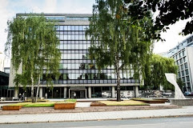

Handing in amendments and textual changes
Guidance and instruction meeting with Committee Presidents

12.00-13.00 Lunch at NHO (tbc)

14.00-17.00 Sightseeing for students and teachers/directors

Dinner for students with host families
Dinner for teachers/directors at Knut and Ellen Gundersen, Bevens løkke 4, 0254 Oslo

Saturday October 10

09.00 General Assembly at Stortinget (Norwegian Parliament)
Karl Johans gate 22, 0026 Oslo, Norge. www.stortinget.no
Delegates and teachers have to present at 8.30 due to security procedures. All participants must bring ID with picture.
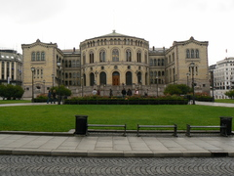

Speakers:
- Mr. Svein Roald Hansen, Vice-President of the Norwegian Parliament
- Ms. Elisabeth Tronstad, Stats Secretary at the Prime Minister’s Office

9.30 Three resolutions in the morning (coffee break in between)

12.00 Lunch in Vandrehallen

13.00 General Assembly continued
Three resolutions in the afternoon (coffee breaks in between)

16.30 Closing Ceremony

Speakers:
- Ms. Astrid Ytre-Eide, President of the General Assembly
- Ms. Nina Nørgaard, Administrative Coordinator of MEP BSR

18.00-20.00 Farewell party with dinner at Nesbru vgs

Sunday October 11

Departure all delegations

www.mepbsr.org

