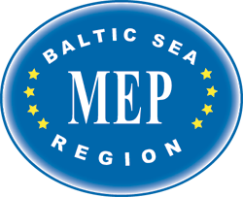

MEP BSR Tartu, Estonia, March 2014

TRAVEL INFORMATION

Country
Name accompanying  Director / Teacher |  male  female
Full private address
School address
Mob. tel. nr.
E-mail address
Arrival | day :  hour :  airline :  flightno:  flight from:  train:  bus:
Departure | day :  hour :  airline :  flightno:  flight to:  train:  bus:

