MEP BSR Stockholm, Sweden, October 2014
TRAVEL INFORMATION
Country
Name accompanying  Director / Teacher | Male  Female
Full private address
School address
Mob. Tel. Nr.
E-mail address

Departure  Day:  Hour:  Airline:  Flight no.:  Flight to:  Train:  Bus: | Arrival  Day:  Hour:  Airline:  Flight no.:  Flight to:  Train:  Bus:

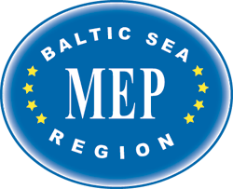
Please fill this form carefully and return to nina.norgaard@live.com
as soon as possible.

