

**Model European Parliament Baltic Sea Region**

**Oslo, Norway, Oct 6-11, 2015**

**Tuesday October 6**

Before 17.00 Arrival of delegates and teachers/directors at

Nesbru videregående skole

Halvard Torgersensvei 8, 1378 Nesbru, [www.nesbru.vgs.no](http://www.nesbru.vgs.no)

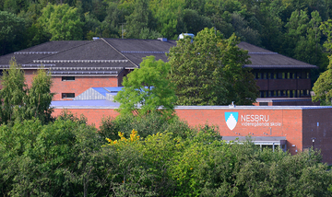

Host parents pick up delegates from 17.00. Dinner with host families.

Teachers/directors stay in Cochs Pensjonat, Parkveien 25 N, 0350 Oslo, [www.cochspensjonat.no](http://www.cochspensjonat.no)

**Wednesday October 7**

09.00-11.00 Opening Ceremony at Asker Town Hall, Knud Askers vei 24, 1371 Asker,

[www.asker.kommune.no](http://www.asker.kommune.no)

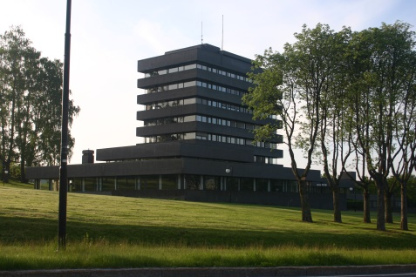

Speakers:

* Mr. Dan Gustafsson, Chairman of the Board / MEP BSR
* Mr. Knut Jore, Headmaster of Nesbru VGS tbc
* Heads of Delegations

11.00-12.00 Teambuilding

12.00-13.00 Lunch in committees at Nesbru VGS

13.30-18.00 Committee meetings at Nesbru VGS

13.30-15.30 MEP BSR Board Meeting for teachers/directors at Nesbru VGS

Dinner with host families

**Thursday October 8**

09.00-12.00 Committee meetings continued at Nesbru VGS

12.00-13.00 Lunch at school

13.00-16.00 Committee meetings continued

16.00 Resolutions to be handed in

16.00-18.00 Correction panel, printing, Nesbru VGS

20.00-22.00 Buffet Dinner and Cultural Program at Nesbru VGS

**Friday October 9**

09.00-12.00 Delegation Meetings and lobbying at Næringslivets Hovedorganisasjon –

NHO, Middelthuns gate 27, 0368 Oslo, [www.nho.no](http://www.nho.no)

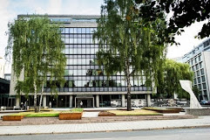

Handing in amendments and textual changes

Guidance and instruction meeting with Committee Presidents

12.00-13.00 Lunch at NHO

13.00-16.00 Sightseeing for delegates and teachers/directors

Dinner with host families

**Saturday October 10**

09.00-17.00 General Assembly at Stortinget (Norwegian Parliament)

Karl Johans gate 22, 0026 Oslo, Norge. [www.stortinget.no](http://www.stortinget.no)

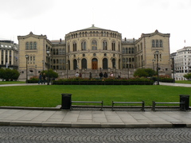

Speakers: tbc

Three resolutions in the morning (Coffee breaks)

Lunch

General Assembly continued

Three resolutions in the afternoon (Coffee breaks)

16.30 Closing Ceremony

Speakers:

* Ms. Astrid Ytre-Eide, President of the General Assembly
* Ms. Nina Nørgaard, Administrative Coordinator of MEP BSR

19.00-21.00 Farewell party with dinner

**Sunday October 11**

Departure all delegations

www.mepbsr.org

