MEP Session in Stockholm, Sweden (draft, August)
October 4 – 9 , 2014

Program:

Saturday October 4

Before 17.00 Arrival of delegates and teachers/directors at Victor Rydberg Djursholm,
Viktor Rydbergs Väg 31, 182 62 Djursholm, Stockholm, www.vrg.se

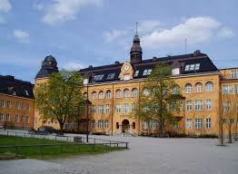

Host parents pick up delegates from 17.00. Dinner with host families.
Teachers/directors stay in hotel in Stockholm City center (transport provided from the school). Will be announced shortly.

Sunday October 5

09.00-11.00 Opening Ceremony at Djursholm Castle (near the school)

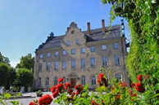

Speakers:
- Mr. Dan Gustafsson, Chairman of the Board of MEP BSR
- Ms. Birgitta Olsson, EU Minister (TBC)

- Heads of Delegations

11.00-12.00 Teambuilding

12.00-13.00 Lunch committee wise at Victor Rydberg Djursholm

13.30-18.00 Committee meetings at Victor Rydberg Djursholm

Dinner with host families

Monday October 6

09.00-12.00 Committee meetings continued in one of the VRG schools, Djursholm or Stockholm City center

12.00-13.00 Lunch at school

13.00-15.00 Committee meetings continued

15.00 Resolutions to be handed in at 15.00

15.00-18.00 Correction panel, printing, Victor Rydberg Djursholm

20.00-22.00 Buffet Dinner and Cultural Program at Victor Rydberg Djursholm

Tuesday October 7

09.00-12.00 Delegation Meetings and lobbying at Djursholms Forörsamlingshem

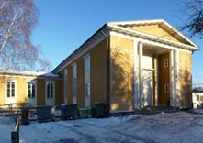

Coffee/tea, snacks, refreshments
Handing in amendments and textual changes
Guidance and instruction meeting with Committee Presidents

12.00- Free time for delegates

13.00-15.00 MEP BSR Board Meeting for teachers/directors at Victor Rydberg Djursholm

Wednesday October 8

09.00-17.00 General Assembly at Landstinssalen, Kungsholmen (TBC)

Speakers:
- Mr. Hans Lindemann, MEP BSR
- Mr. Olle Reichenberg, Head of Danderyd Municipality
- President of the GA

Three resolutions in the morning (Small coffee breaks in between)

Lunch

General Assembly continued
Three resolutions in the afternoon (Small coffee breaks in between)

16.30 Closing Ceremony

Speakers:

- Ms. Nina Nørgaard, Administrativ Coordinator of MEP BSR

19.00-21.00 Farewell party with dinner

Thursday October 9

Departure all delegations

www.mepbsr.org

